**Module- 2**

Submitted By – Sujata Singh

Date of Submission – 25/08/2024

Date of Resubmission –

Batch No – SA2406007

Submitted To – Vikul Mentor

**2. L2** -**As a Linux root user Create Files/Directory**

**in the same Instance and change the ownership to**

**a new user.**

**Step-1**: Login to the AWS Console:

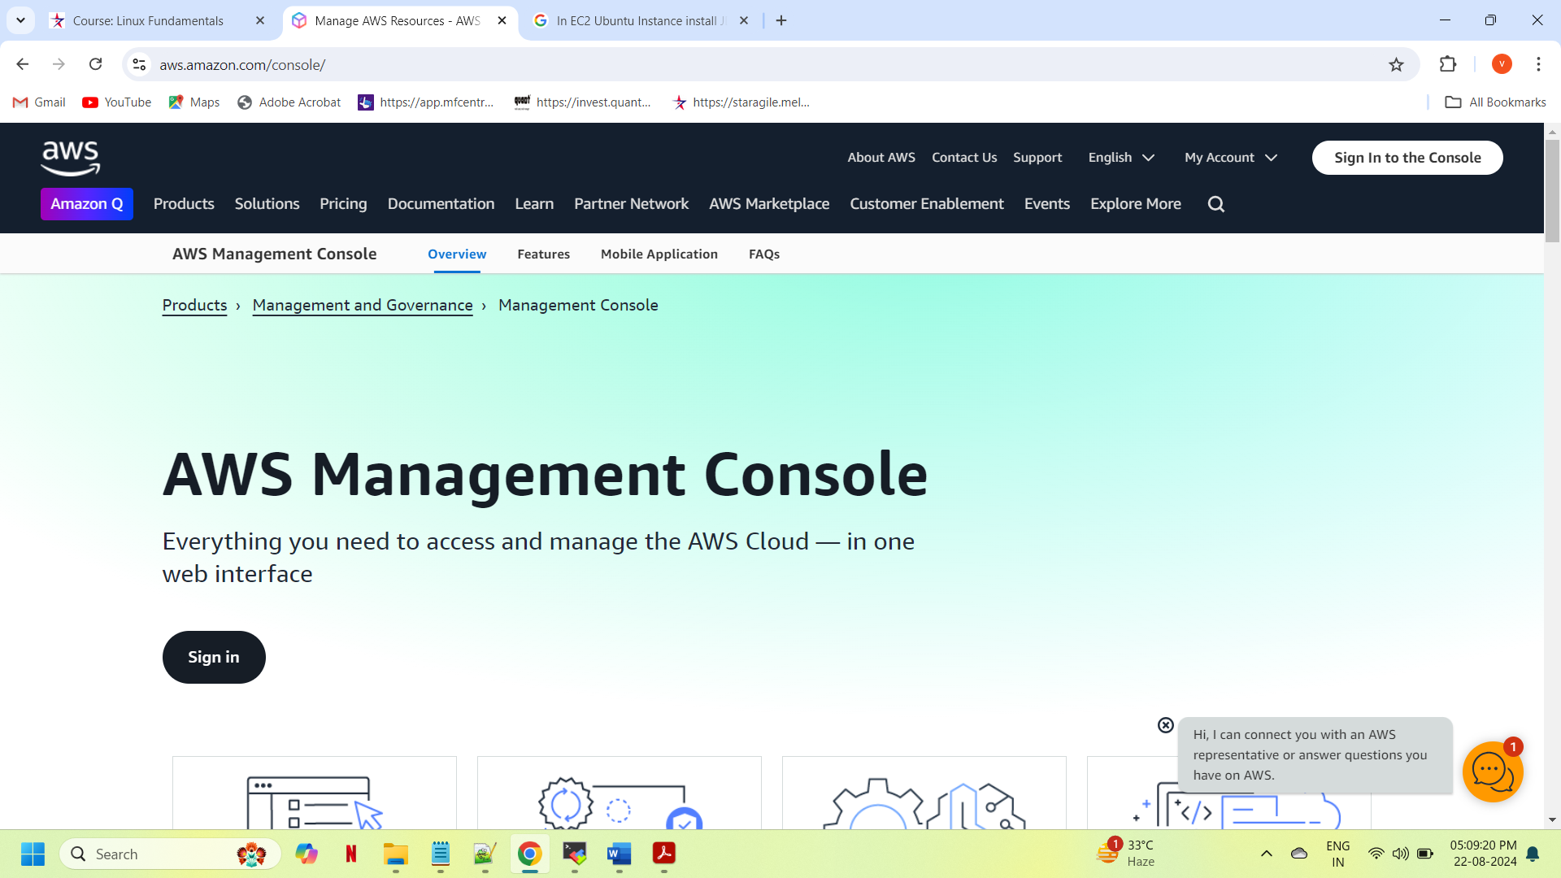

**Step-2**: Login with your credentials (Email id & Password) as a root user.

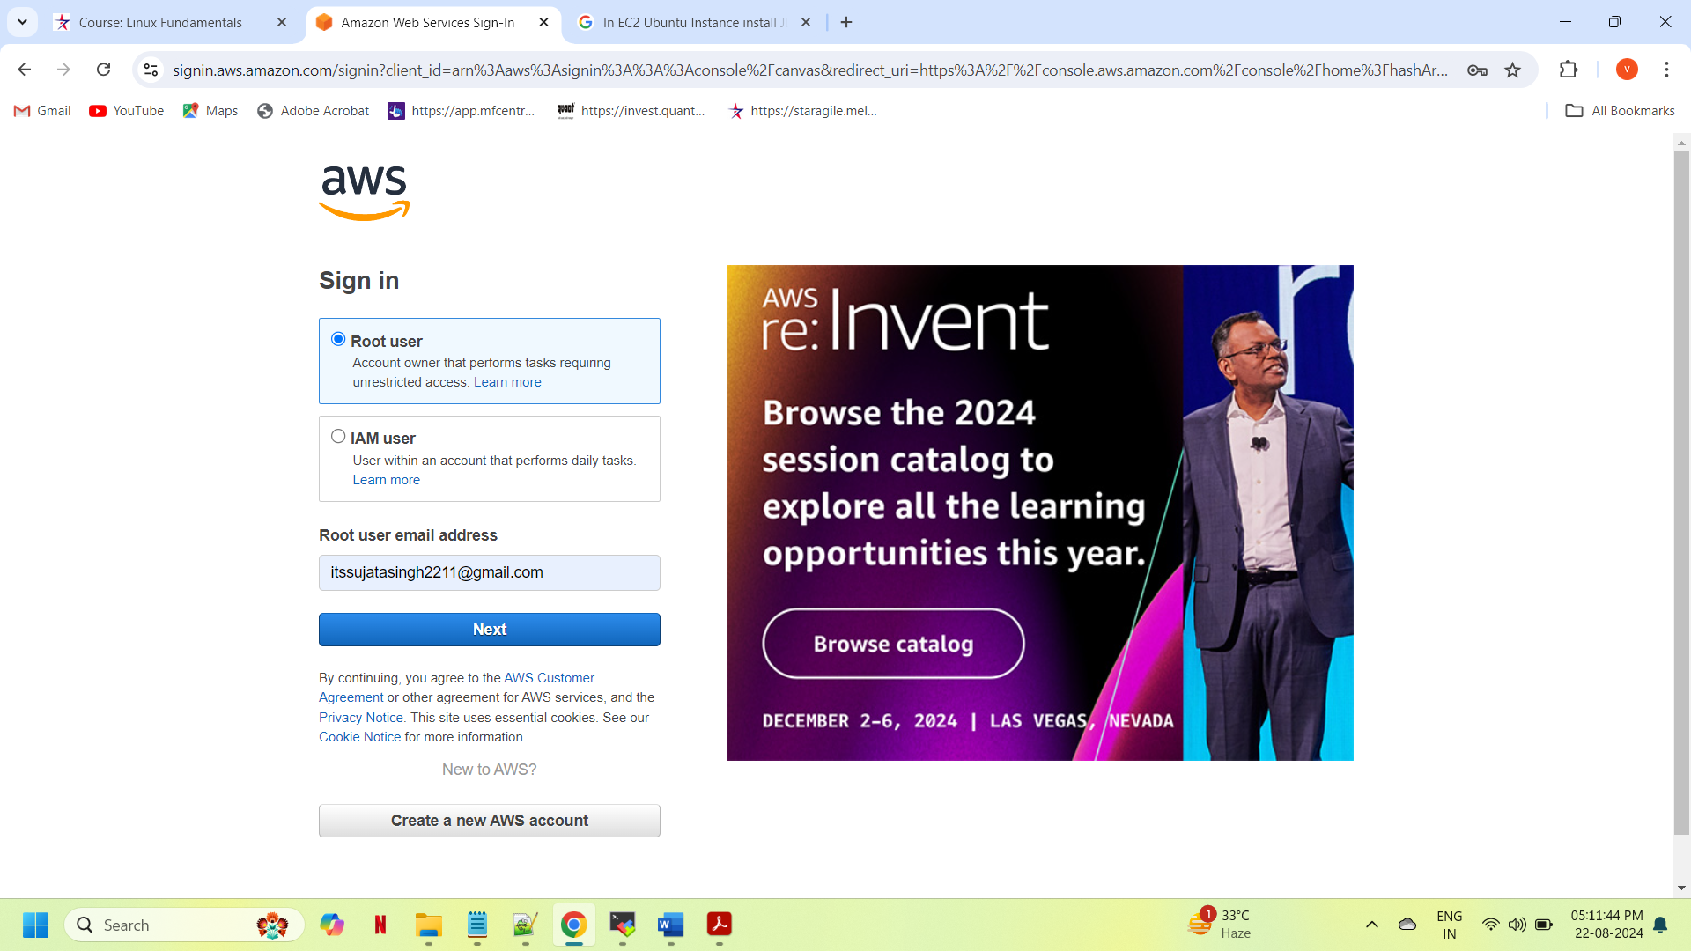

**Step-3**: We will get the AWS console home page, then we will search the keyword like EC2. We will get the EC2 service.

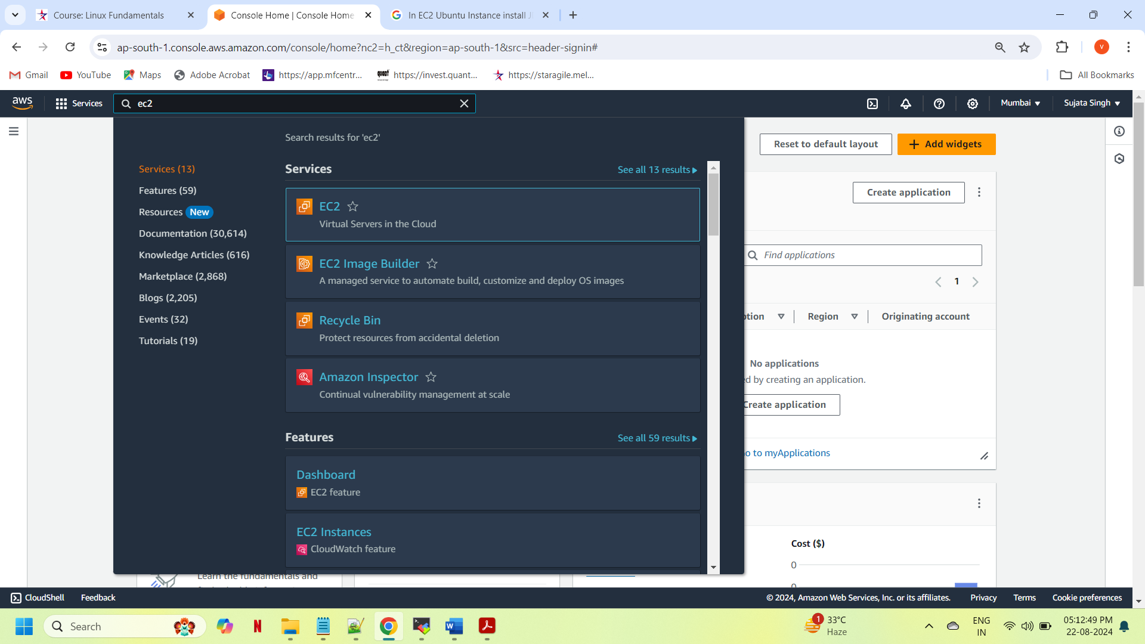

**Step-4:** Once we will click on the EC2 service we will get EC2 dashboard. On EC2 dashboard click on the ***launch instance*** highlighted in yellow on the dashboard.

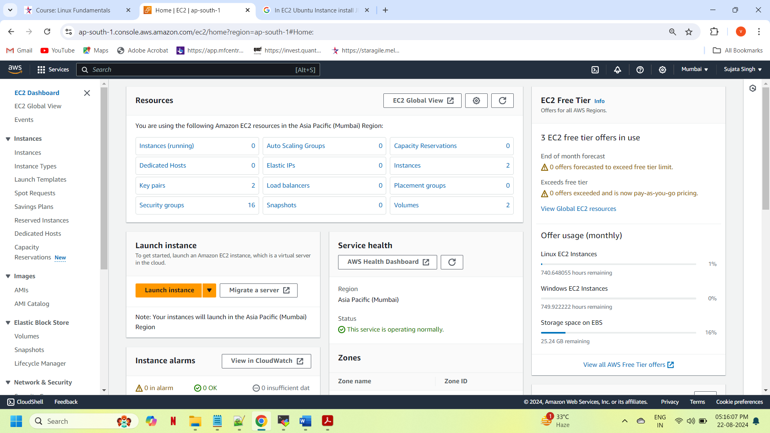

**Step-5**: Now we will launch ubuntu instance, we will require to give the name of the instance, select **ubuntu 22.04 LTS**, Instance Type- **t2. micro**, key-pairs**- SA-ubuntu**, Network Settings, configure storage and some Advance options we don’t need we can keep as it is. Then we just need to click on lunch instance button.

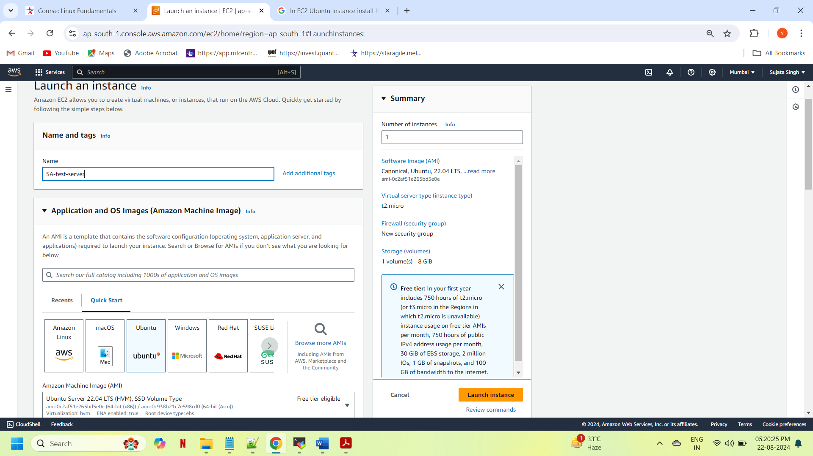

**Step-6:**  Click on the instances option, we will get our newly created ubuntu instance name as **SA-test-server**. Click on checkbox, we can see the public ip address for the instance.

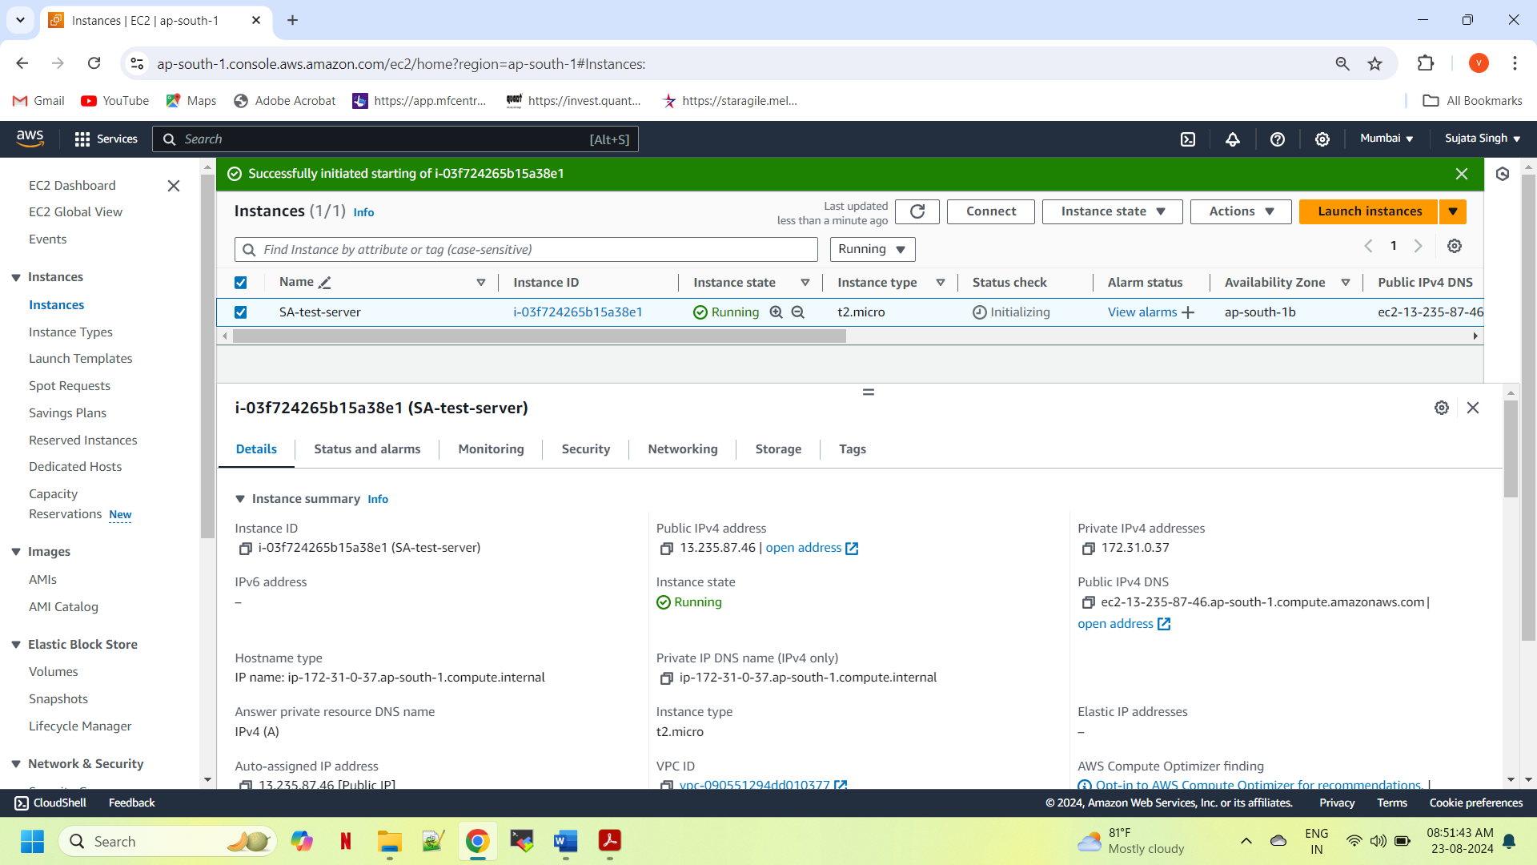

**Step-7:** To connect the instance with Mobaxterm, we required the Public IP of the instance and the key-pairs that we have downloaded while creating the instance.

We required some details to connect mobaxterm as given below:

Remote Host-Public IP i.e. **13.235.87.46**

Specify Username-**ubuntu**

port as **22 for SSH**

**Advance SSH settings.**

Now, we need to click on checkbox like ***Use private key.*** Once we click there, it will allow us to browse the files where we have downloaded the key-pairs for this instance in our local. Then just simply click on **OK** button

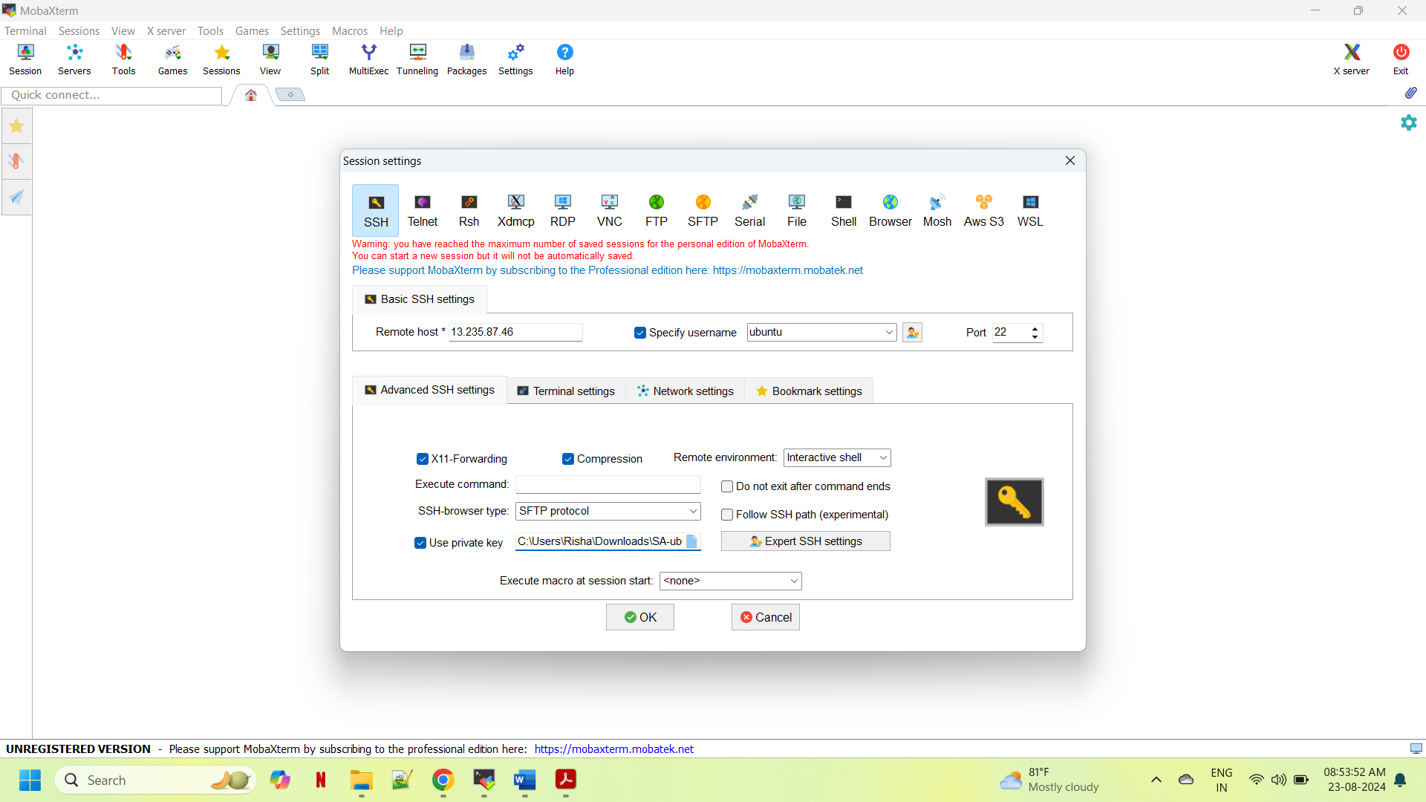

**Step-8**: And now our ubuntu instance is connected to Mobaxterm, first login as root user by using **sudo -i** command and create a file by using **touch maahi.txt** (file_name) and directory by using **mkdir vibhavdir1** (directory­_name) and we can check list by using **ls** command.

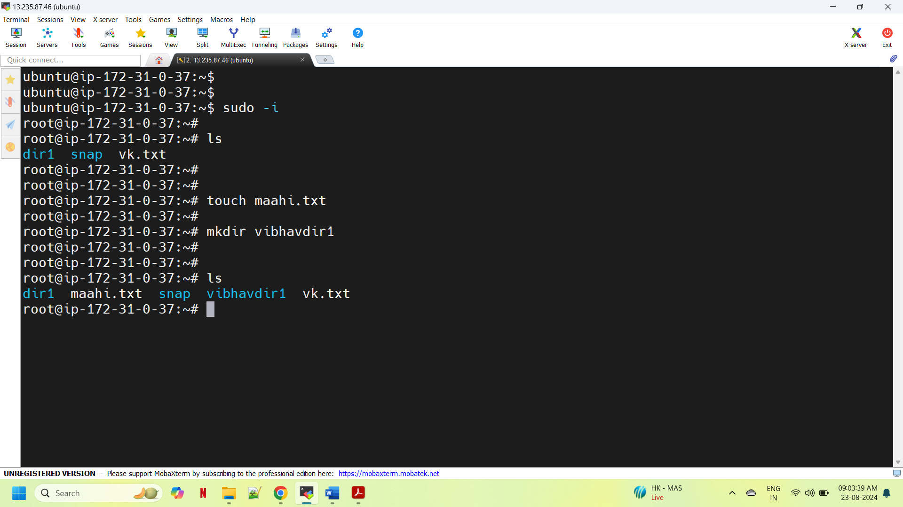

**Step-9**: Then we will create new user named as **“gopaladmin”** by using **useradd gopaladmin -s /bin/bash -m -d /home/gopaladmin** command, then we need to login as gopaladmin by using **su - gopaladmin** command.

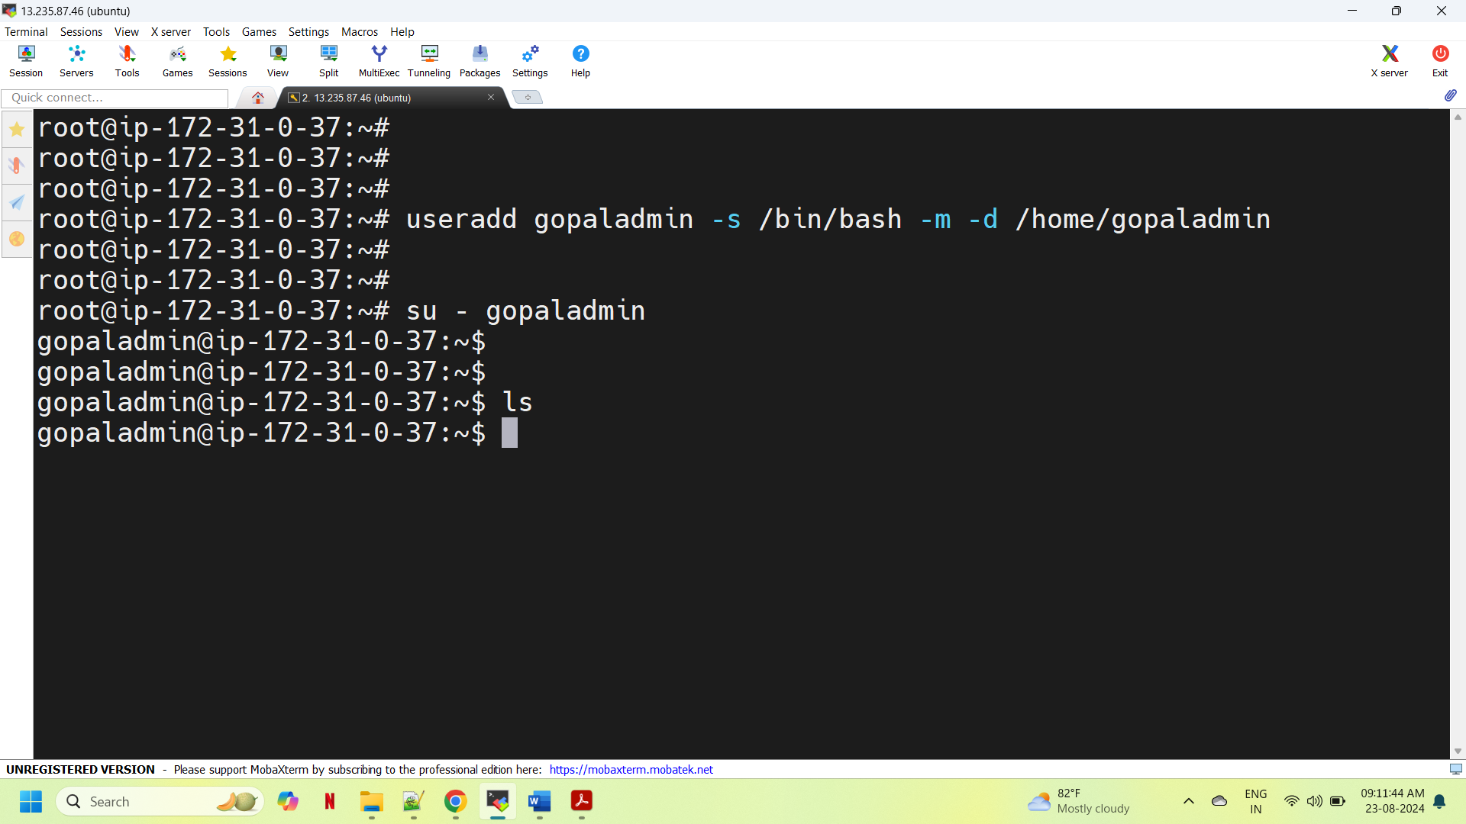

**Step-13**: Now we have **exited** from user(gopaladmin), we will use command **ll** for long list, we can see the owner and group is showing as root user.

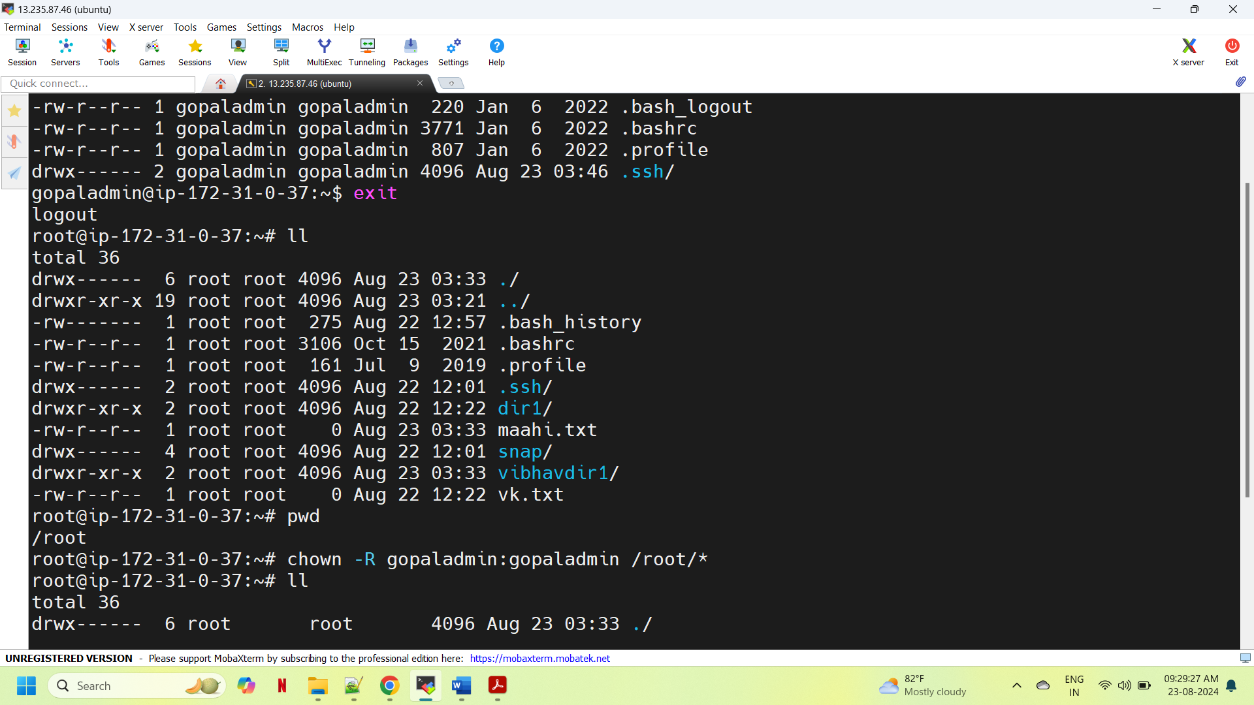

**Step-14**: After that we need to change the ownership as a new user by using chown -R gopaladmin:gopaladmin /root/* now we can see the owner and group has been changed, we can checked by using **ll** command.

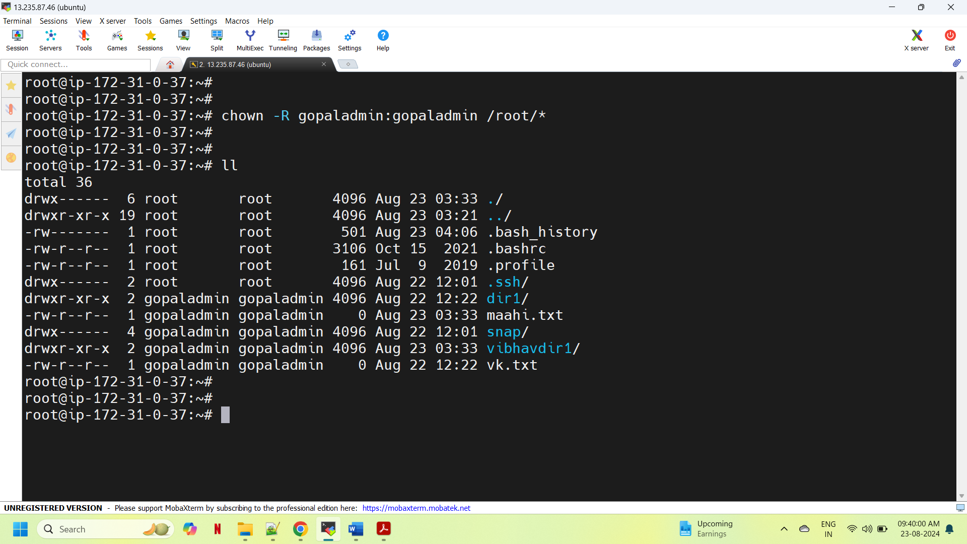

**Thankyou…!!!!!**